**JENKINS IN CLOUD HEROKU**

You need to download Jenkins for java

<https://www.jenkins.io/download/>

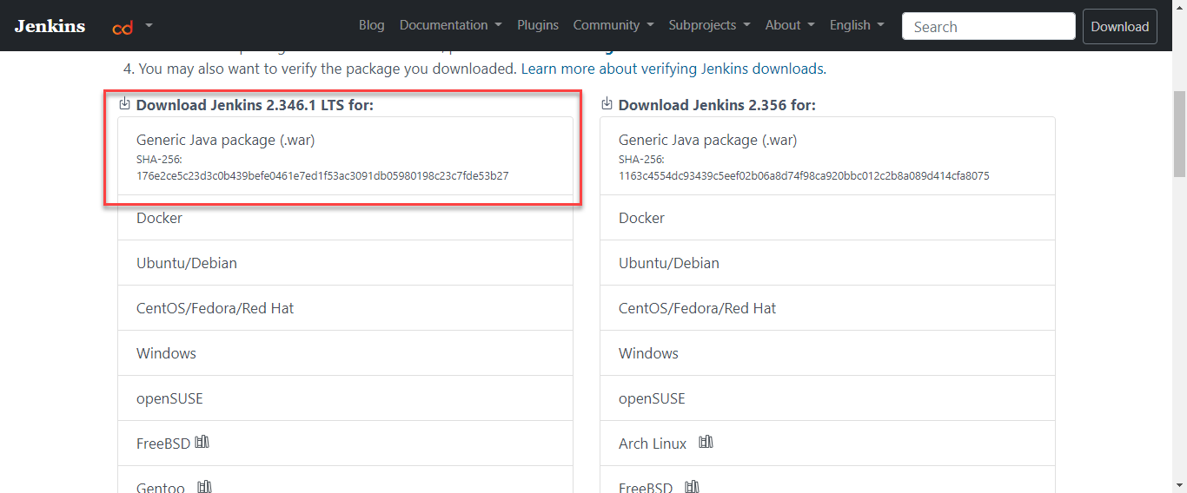

Then you need to create an account in Heroku.

From you Visual Studio apply this commands to upload your Jenkins on the cloud.

cisco@PC1 MINGW64 /d/CODEX/jnks (main)

$ heroku login

» Warning: heroku update available from 7.53.0 to 7.60.2.

heroku: Press any key to open up the browser to login or q to exit:

Opening browser to https://cli-auth.heroku.com/auth/cli/browser/8c7ce-4320-9280-963?requestor=SFMyNTY.g2gDbQAAAA4xOTIuMjI2LjEzNC42N24GAMCftZ6BAWIAAVGA.vr43S0if-roN5yB1_SIDU

Logging in... done

Logged in as

cisco@PC1 MINGW64 /d/CODEX/jnks (main)

$ ls

jenkins.war

cisco@PC1 MINGW64 /d/CODEX/jnks (main)

$ heroku plugin:install java

» Warning: heroku update available from 7.53.0 to 7.60.2.

» Warning: plugin:install is not a heroku command.

Did you mean plugins:install? [y/n]: y

warning @heroku-cli/plugin-java > heroku-exec-util > uuid@3.2.1: Please upgrade to version 7 or higher. Older versions may use Math.random() in certain circumstances, which is known to be problematic. See https://v8.dev/blog/math-random for details.

Installing plugin java... installed v3.1.1

cisco@PC1 MINGW64 /d/CODEX/jnks (main)

$ heroku create java-jenkins

» Warning: heroku update available from 7.53.0 to 7.60.2.

Creating ⬢ java-jenkins... done

https://java-jenkins.herokuapp.com/ | <https://git.heroku.com/java-jenkins.git>

cisco@PC1 MINGW64 /d/CODEX/jnks (main)

$ heroku deploy:war jenkins.war -a java-jenkins

» Warning: heroku update available from 7.53.0 to 7.60.2.

Uploading jenkins.war

-----> Packaging application...

- app: java-jenkins

- including: webapp-runner.jar

- including: jenkins.war

-----> Creating build...

- file: slug.tgz

- size: 107MB

-----> Uploading build...

- success

-----> Deploying...

remote:

remote: -----> Building on the Heroku-20 stack

remote: -----> Using buildpack: heroku/jvm

remote: -----> heroku-deploy app detected

remote: -----> Installing OpenJDK 1.8... done

remote: -----> Discovering process types

remote: Procfile declares types -> buildpacks, war, web

remote:

remote: -----> Compressing...

remote: Done: 159.3M

remote: -----> Launching...

remote: Released v3

remote: https://java-jenkins.herokuapp.com/ deployed to Heroku

remote:

remote: This app is using the Heroku-20 stack, however a newer stack is available.

remote: To upgrade to Heroku-22, see:

remote: https://devcenter.heroku.com/articles/upgrading-to-the-latest-stack

remote:

-----> Done

ENJOYING !!! ☺

